SEC Form 3
FORM 3 | UNITED STATES SECURITIES AND EXCHANGE COMMISSION
 | Washington, D.C. 20549
 | Washington, D.C. 20549 |  | OMB APPROVAL
 | INITIAL STATEMENT OF BENEFICIAL OWNERSHIP OF SECURITIES
 | INITIAL STATEMENT OF BENEFICIAL OWNERSHIP OF SECURITIES |  | OMB Number: | 3235-0104
 |  |  | Estimated average burden
 | Filed pursuant to Section 16(a) of the Securities Exchange Act of 1934 |  | hours per response: | 0.5
or Section 30(h) of the Investment Company Act of 1940
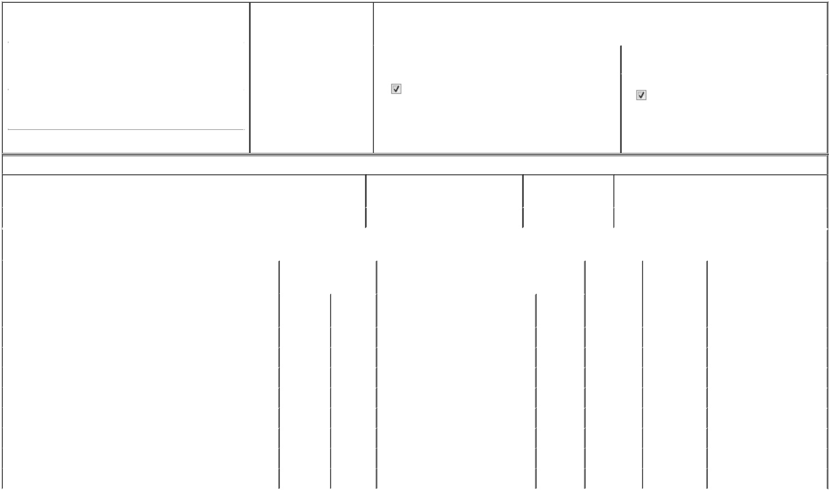

1. Name and Address of Reporting Person* |  |  |  |  |  | 2. Date of Event Requiring
 |  | O'Loughlin Senan |  |  |  | Statement (Month/Day/Year)
 |  |  |  |  | 06/22/2026
 |  | (Last) | (First) |  | (Middle)
 |  | 16600 SWINGLEY RIDGE ROAD
(Street)
 |  | CHESTERFIELD MO |  |  | 63017

3. |  | Issuer Name and Ticker or Trading Symbol
REINSURANCE GROUP OF AMERICA INC [ RGA ]
4. |  | Relationship of Reporting Person(s) to Issuer |  |  | 5. | If Amendment, Date of Original Filed (Month/Day/Year)
(Check all applicable)
 |  | Director | 10% Owner
 |  | Director |  |  | 6. | Individual or Joint/Group Filing (Check Applicable Line)
 |  | Officer (give title | Other (specify below) |  | 6. | Individual or Joint/Group Filing (Check Applicable Line)
 |  | below) |  |  |  | Form filed by One Reporting Person
 |  | Executive Vice President |  |  |  | Form filed by More than One Reporting Person

(City) (State) (Zip)

Table I - Non-Derivative Securities Beneficially Owned

1. Title of Security (Instr. 4) | 2. Amount of Securities Beneficially | 3. Ownership Form: | 4. Nature of Indirect Beneficial Ownership (Instr. 5)
 | Owned (Instr. 4) | Direct (D) or Indirect
 |  | (I) (Instr. 5)

 | Common Stock |  |  |  | 2,967.412 | D
 |  |  | Table II - Derivative Securities Beneficially Owned
 |  | (e.g., puts, calls, warrants, options, convertible securities)
 | 1. Title of Derivative Security (Instr. 4) |  | 2. Date Exercisable and |  | 3. Title and Amount of Securities Underlying |  | 4. | 5. Ownership | 6. Nature of Indirect Beneficial
 |  |  | Expiration Date |  | Derivative Security (Instr. 4) |  | Conversion | Form: Direct | Ownership (Instr. 5)
 |  |  | (Month/Day/Year) |  |  |  | or Exercise | (D) or Indirect
 |  |  |  |  |  |  | Price of | (I) (Instr. 5)
 |  |  |  |  |  | Amount or | Price of | (I) (Instr. 5)
 |  |  |  |  |  | Amount or | Derivative
 |  |  | Date | Expiration | Title | Number of | Security
 |  |  | Exercisable | Date | Title | Shares
 | Restricted Share Unit - March 2026 | (1) |  | (1) | Common Stock | 539 | ₀(2) | D
 | Restricted Share Unit - March 2025 | (3) |  | (3) | Common Stock | 291 | ₀(2) | D
 | Restricted Share Unit - March 2024 | (4) |  | (4) | Common Stock | 142 | ₀(2) | D
 | Stock Appreciation Right (right to purchase) 2026 | (1) |  | 03/19/2036 | Common Stock | 1,556 | 200.5 | D
 | Stock Appreciation Right (right to purchase) 2025 | (3) |  | 03/06/2035 | Common Stock | 1,190 | 193 | D
 | Stock Appreciation Right (right to purchase) 2024 | (4) |  | 03/15/2034 | Common Stock | 1,081 | 185.28 | D
 | Stock Appreciation Right (right to purchase) 2023 | (5) |  | 03/09/2033 | Common Stock | 964 | 138.34 | D
 | Stock Appreciation Right (right to purchase) 2022 | (5) |  | 03/22/2032 | Common Stock | 1,263 | 106.53 | D
 | Explanation of Responses:

- Stock appreciation rights and restricted share units settle in common stock, vest in 33 1/3% increments, beginning on the first anniversary date of the grant, and fully vest on March 19, 2029.

- Each restricted stock unit represents a contingent right to receive one (1) share of the Issuer's common stock upon vesting.

- Stock appreciation rights and restricted share units settle in common stock, vest in 33 and 1/3% increments over three years, and fully vest on December 31, 2027.

- Stock appreciation rights and restricted share units settle in common stock, vest in 33 and 1/3% increments over three years, and fully vest on December 31, 2026.

- Stock appreciation rights settle in common stock and vest in 25% increments, over four years, beginning on December 31 of the year of grant.

Remarks:

 | /s/ My Chi To, by Power of Attorney |  | 07/02/2026
 | ** Signature of Reporting Person |  |  | Date
Reminder: Report on a separate line for each class of securities beneficially owned directly or indirectly.
* If the form is filed by more than one reporting person, see Instruction 5 (b)(v).
** Intentional misstatements or omissions of facts constitute Federal Criminal Violations See 18 U.S.C. 1001 and 15 U.S.C. 78ff(a).
Note: File three copies of this Form, one of which must be manually signed. If space is insufficient, see Instruction 6 for procedure.
Persons who respond to the collection of information contained in this form are not required to respond unless the form displays a currently valid OMB Number.



