SEC Form 4
FORM 4 |  | UNITED STATES SECURITIES AND EXCHANGE COMMISSION  Washington, D.C. 20549  STATEMENT OF CHANGES IN BENEFICIAL OWNERSHIP  Filed pursuant to Section 16(a) of the Securities Exchange Act of 1934  or Section 30(h) of the Investment Company Act of 1940
  OMB APPROVAL
  OMB Number: | 3235-0287
  Estimated average burden
  hours per response: | 0.5
 | Check this box if no longer subject to Section 16. Form 4 or Form 5 obligations may continue. See Instruction 1(b).
 | Check this box to indicate that a transaction was made pursuant to a contract, instruction or written plan for the purchase or sale of equity securities of the issuer that is intended to satisfy the affirmative defense conditions of Rule 10b5-1(c). See Instruction 10.
1. Name and Address of Reporting Person*  (Street) | 2. Issuer Name and Ticker or Trading Symbol  REINSURANCE GROUP OF AMERICA INC [ RGA ] | 5. Relationship of Reporting Person(s) to Issuer  (Check all applicable)
  TULLOCH MAURICE
  (Last) | (First) | (Middle)
  16600 SWINGLEY RIDGE ROAD
  CHESTERFIELD | MO | 63017
  (City) | (State) | (Zip)
   | Director |  | 10% Owner
   | Officer (give title below) |  | Other (specify below)
3. Date of Earliest Transaction (Month/Day/Year)
07/01/2026
 | 4. If Amendment, Date of Original Filed (Month/Day/Year) | 6. Individual or Joint/Group Filing (Check Applicable Line)
  Form filed by One Reporting Person
  Form filed by More than One Reporting Person
Table I - Non-Derivative Securities Acquired, Disposed of, or Beneficially Owned
1. Title of Security (Instr. 3) | 2. Transaction Date (Month/Day/Year) | 2A. Deemed Execution Date, if any (Month/Day/Year) | 3. Transaction Code (Instr. 8) |  | 4. Securities Acquired (A) or Disposed Of (D) (Instr. 3, 4 and 5) |  |  | 5. Amount of Securities Beneficially Owned Following Reported Transaction(s) (Instr. 3 and 4) | 6. Ownership Form: Direct (D) or Indirect (I) (Instr. 4) | 7. Nature of Indirect Beneficial Ownership (Instr. 4)
1. Title of Security (Instr. 3) | 2. Transaction Date (Month/Day/Year) | 2A. Deemed Execution Date, if any (Month/Day/Year) | Code | V | Amount | (A) or (D) | Price |  | 6. Ownership Form: Direct (D) or Indirect (I) (Instr. 4) | 7. Nature of Indirect Beneficial Ownership (Instr. 4)
Common Stock | 07/01/2026 |  | A |  | 406(1) | A | $215.65 | 406 | D
Table II - Derivative Securities Acquired, Disposed of, or Beneficially Owned
(e.g., puts, calls, warrants, options, convertible securities)
1. Title of Derivative Security (Instr. 3) | 2. Conversion or Exercise Price of Derivative Security | 3. Transaction Date (Month/Day/Year) | 3A. Deemed Execution Date, if any (Month/Day/Year) | 4. Transaction Code (Instr. 8) |  | 5. Number of Derivative Securities Acquired (A) or Disposed of (D) (Instr. 3, 4 and 5) |  | 6. Date Exercisable and Expiration Date (Month/Day/Year) |  | 7. Title and Amount of Securities Underlying Derivative Security (Instr. 3 and 4) |  | 8. Price of Derivative Security (Instr. 5) | 9. Number of derivative Securities Beneficially Owned Following Reported Transaction(s) (Instr. 4) | 10. Ownership Form: Direct (D) or Indirect (I) (Instr. 4) | 11. Nature of Indirect Beneficial Ownership (Instr. 4)
 |  |  |  | Code | V | (A) | (D) | Date Exercisable | Expiration Date | Title | Amount or Number of Shares
Explanation of Responses:
1. The 406 shares of common stock issued to the Reporting Person are part of his non-deferred, prorated annual compensation as a new member of Reinsurance Group of America, Incorporated's Board of Directors, effective July 1, 2026.
Remarks:
 | /s/ My Chi To, by Power of Attorney | 07/06/2026
 | ** Signature of Reporting Person | Date
Reminder: Report on a separate line for each class of securities beneficially owned directly or indirectly.
* If the form is filed by more than one reporting person, see Instruction 4 (b)(v).
** Intentional misstatements or omissions of facts constitute Federal Criminal Violations See 18 U.S.C. 1001 and 15 U.S.C. 78ff(a).
Note: File three copies of this Form, one of which must be manually signed. If space is insufficient, see Instruction 6 for procedure.
Persons who respond to the collection of information contained in this form are not required to respond unless the form displays a currently valid OMB Number.
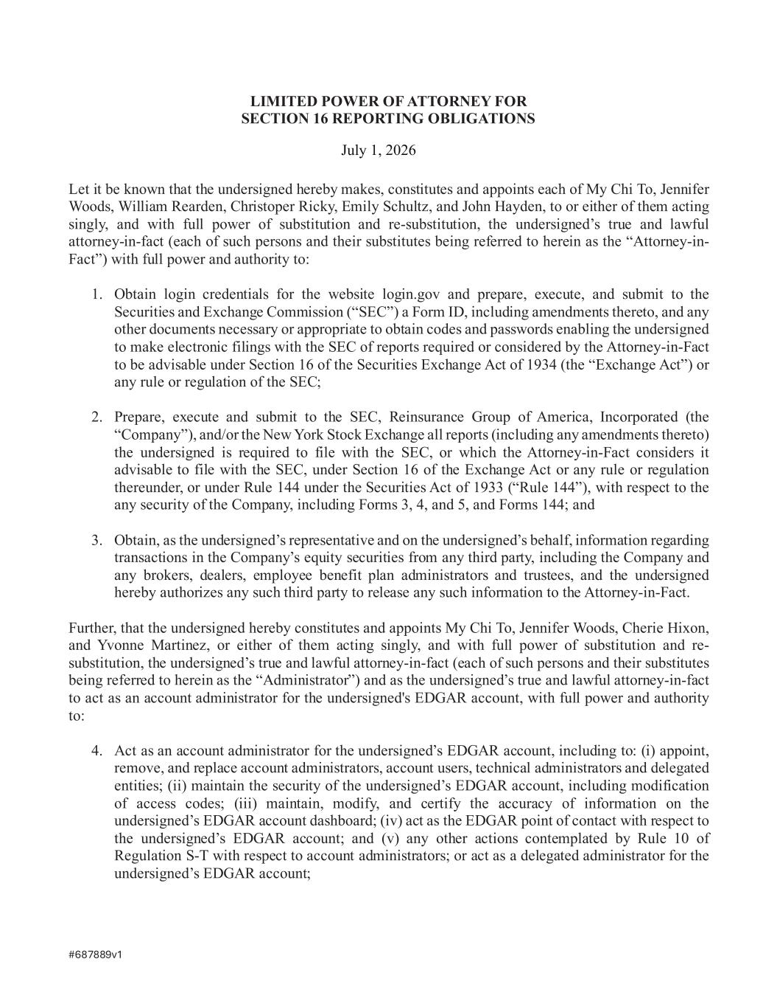
#687889v1 LIMITED POWER OF ATTORNEY FOR SECTION 16 REPORTING OBLIGATIONS Let it be known that the undersigned hereby makes, constitutes and appoints each of My Chi To, Jennifer Woods, William Rearden, Christoper Ricky, Emily Schultz, and John Hayden, to or either of them acting singly, and with full power of substitution and re-substitution, the undersigned’s true and lawful attorney-in-fact (each of such persons and their substitutes being referred to herein as the “Attorney-in- Fact”) with full power and authority to: 1. Obtain login credentials for the website login.gov and prepare, execute, and submit to the Securities and Exchange Commission (“SEC”) a Form ID, including amendments thereto, and any other documents necessary or appropriate to obtain codes and passwords enabling the undersigned to make electronic filings with the SEC of reports required or considered by the Attorney-in-Fact to be advisable under Section 16 of the Securities Exchange Act of 1934 (the “Exchange Act”) or any rule or regulation of the SEC; 2. Prepare, execute and submit to the SEC, Reinsurance Group of America, Incorporated (the “Company”), and/or the New York Stock Exchange all reports (including any amendments thereto) the undersigned is required to file with the SEC, or which the Attorney-in-Fact considers it advisable to file with the SEC, under Section 16 of the Exchange Act or any rule or regulation thereunder, or under Rule 144 under the Securities Act of 1933 (“Rule 144”), with respect to the any security of the Company, including Forms 3, 4, and 5, and Forms 144; and 3. Obtain, as the undersigned’s representative and on the undersigned’s behalf, information regarding transactions in the Company’s equity securities from any third party, including the Company and any brokers, dealers, employee benefit plan administrators and trustees, and the undersigned hereby authorizes any such third party to release any such information to the Attorney-in-Fact. Further, that the undersigned hereby constitutes and appoints My Chi To, Jennifer Woods, Cherie Hixon, and Yvonne Martinez, or either of them acting singly, and with full power of substitution and re- substitution, the undersigned’s true and lawful attorney-in-fact (each of such persons and their substitutes being referred to herein as the “Administrator”) and as the undersigned’s true and lawful attorney-in-fact to act as an account administrator for the undersigned's EDGAR account, with full power and authority to: 4. Act as an account administrator for the undersigned’s EDGAR account, including to: (i) appoint, remove, and replace account administrators, account users, technical administrators and delegated entities; (ii) maintain the security of the undersigned’s EDGAR account, including modification of access codes; (iii) maintain, modify, and certify the accuracy of information on the undersigned’s EDGAR account dashboard; (iv) act as the EDGAR point of contact with respect to the undersigned’s EDGAR account; and (v) any other actions contemplated by Rule 10 of Regulation S-T with respect to account administrators; or act as a delegated administrator for the undersigned’s EDGAR account; July 1, 2026

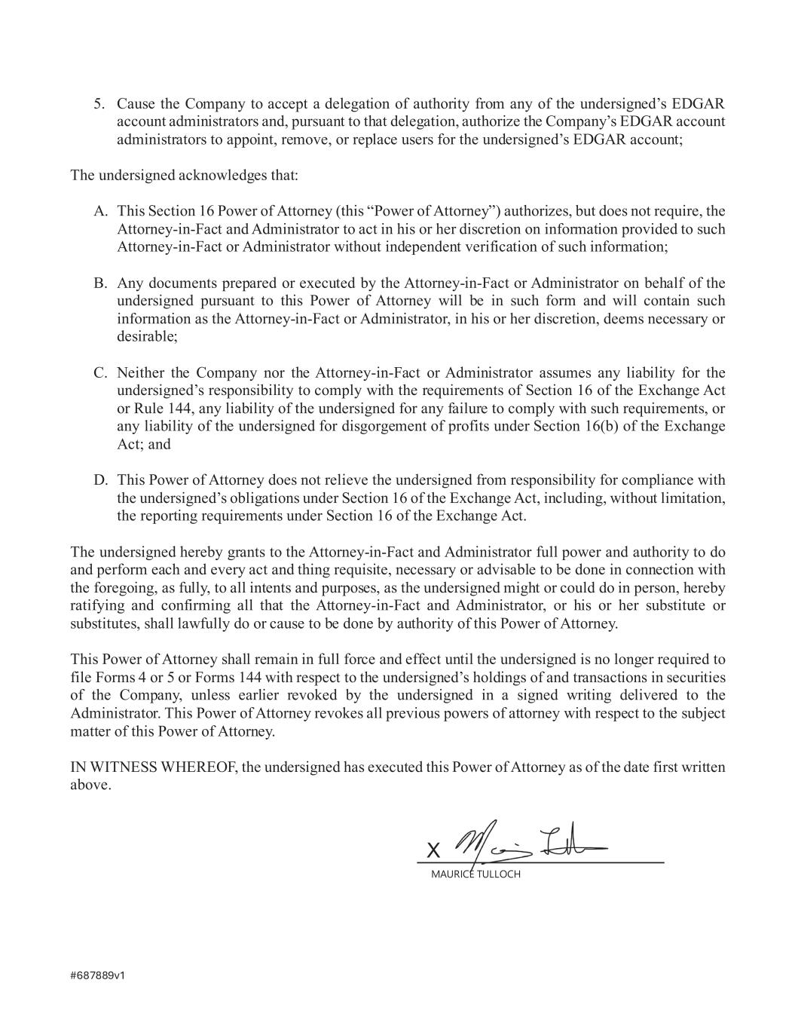
#687889v1 5. Cause the Company to accept a delegation of authority from any of the undersigned’s EDGAR account administrators and, pursuant to that delegation, authorize the Company’s EDGAR account administrators to appoint, remove, or replace users for the undersigned’s EDGAR account; The undersigned acknowledges that: A. This Section 16 Power of Attorney (this “Power of Attorney”) authorizes, but does not require, the Attorney-in-Fact and Administrator to act in his or her discretion on information provided to such Attorney-in-Fact or Administrator without independent verification of such information; B. Any documents prepared or executed by the Attorney-in-Fact or Administrator on behalf of the undersigned pursuant to this Power of Attorney will be in such form and will contain such information as the Attorney-in-Fact or Administrator, in his or her discretion, deems necessary or desirable; C. Neither the Company nor the Attorney-in-Fact or Administrator assumes any liability for the undersigned’s responsibility to comply with the requirements of Section 16 of the Exchange Act or Rule 144, any liability of the undersigned for any failure to comply with such requirements, or any liability of the undersigned for disgorgement of profits under Section 16(b) of the Exchange Act; and D. This Power of Attorney does not relieve the undersigned from responsibility for compliance with the undersigned’s obligations under Section 16 of the Exchange Act, including, without limitation, the reporting requirements under Section 16 of the Exchange Act. The undersigned hereby grants to the Attorney-in-Fact and Administrator full power and authority to do and perform each and every act and thing requisite, necessary or advisable to be done in connection with the foregoing, as fully, to all intents and purposes, as the undersigned might or could do in person, hereby ratifying and confirming all that the Attorney-in-Fact and Administrator, or his or her substitute or substitutes, shall lawfully do or cause to be done by authority of this Power of Attorney. This Power of Attorney shall remain in full force and effect until the undersigned is no longer required to file Forms 4 or 5 or Forms 144 with respect to the undersigned’s holdings of and transactions in securities of the Company, unless earlier revoked by the undersigned in a signed writing delivered to the Administrator. This Power of Attorney revokes all previous powers of attorney with respect to the subject matter of this Power of Attorney. IN WITNESS WHEREOF, the undersigned has executed this Power of Attorney as of the date first written above. X MAURICE TULLOCH

